Mechatronic System Components and Technologies
Assignment Template LO2
Akbar Qamar
Sample Document

Contents
1. Introduction (200 words) 2
2. Sensors and Transducers (400–500 words) 3
3. Actuators (300–400 words) 4
4. Signal Types and Processing (500–600 words) 5
5. Compliance and Standards (200 words) 6
6. Conclusion & Recommendations (200 words) 7

Introduction (200 words)
Briefly describe the manufacturing scenario (client’s needs: temperature, pressure, position control).
State the purpose of the report (selection of components, signal processing, justification).

Sensors and Transducers (400–500 words)
Identify and justify sensors/transducers utilized in the robotic arm you worked on and justify the chosen devices against alternatives available on the market, you can’t talk about devices in hardware in isolation.
- **Precision** (e.g., ±0.1°C for temperature).
- **Environmental factors** (e.g., vibration, EMI resistance).
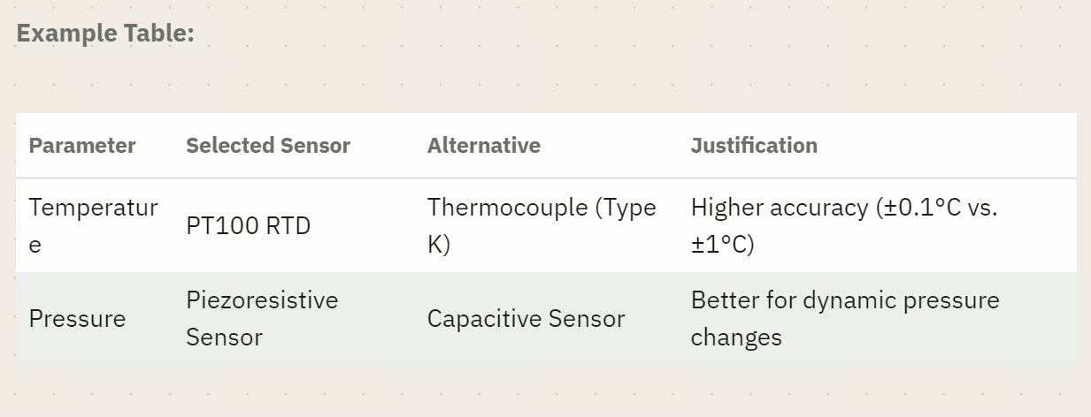
- **Calibration needs** (e.g., RTDs require periodic calibration).

Actuators (300–400 words)
Select and justify actuator(s) utilized in your hardware
Motorized adjustments (e.g., stepper, servo, hydraulic actuators).
Tasks:
Compare actuator types (e.g., pneumatic vs. electric for valves).
Justify selections based on:
Force/torque requirements (e.g., hydraulic for high force).
Mounting constraints (e.g., compact servo motors).
NEMA/IEC compliance (e.g., IP67 for dust/water resistance).
Example Justification:
"A servo motor* was selected over a stepper motor for position control due to its closed-loop feedback, ensuring higher precision (±0.01mm)."

Signal Types and Processing (500–600 words)
Signal Types and Processing (500–600 words)
REFER TO PPTs
Objective: Evaluate analogue/digital signals and noise reduction techniques.
A. Signal Types in Instrumentation
Analogue signals (e.g., 4–20mA current loops for pressure sensors).
Digital signals (e.g., PWM for motor control, I²C/SPI for sensor data).
Justify choices (e.g., "4–20mA is immune to voltage drops over long distances.").
B. Signal Processing Techniques
✔ Amplification/Attenuation (e.g., op-amps for weak thermocouple signals).
✔ Filtering (e.g., low-pass filters to remove high-frequency noise).
✔ ADC/DAC (e.g., 16-bit ADC for high-resolution temperature readings).
✔ Shielding & Grounding (e.g., twisted-pair cables to reduce EMI).

5. Compliance and Standards (200 words)
- Discuss **industry standards** (e.g., IEC 61131 for PLCs, NEMA ratings for actuators).
- Explain how your design **minimizes noise** (e.g., shielded cables, differential signalling).

6. Conclusion & Recommendations (200 words)
- Summarize key **component choices** and **signal processing methods**.
- Suggest **future improvements** (e.g., wireless IoT sensors for remote monitoring).

Bibliography
There are no sources in the current document.

